Advantages of Southeast Arkansas, Inc.
Fiscal Year 2026 Annual Report

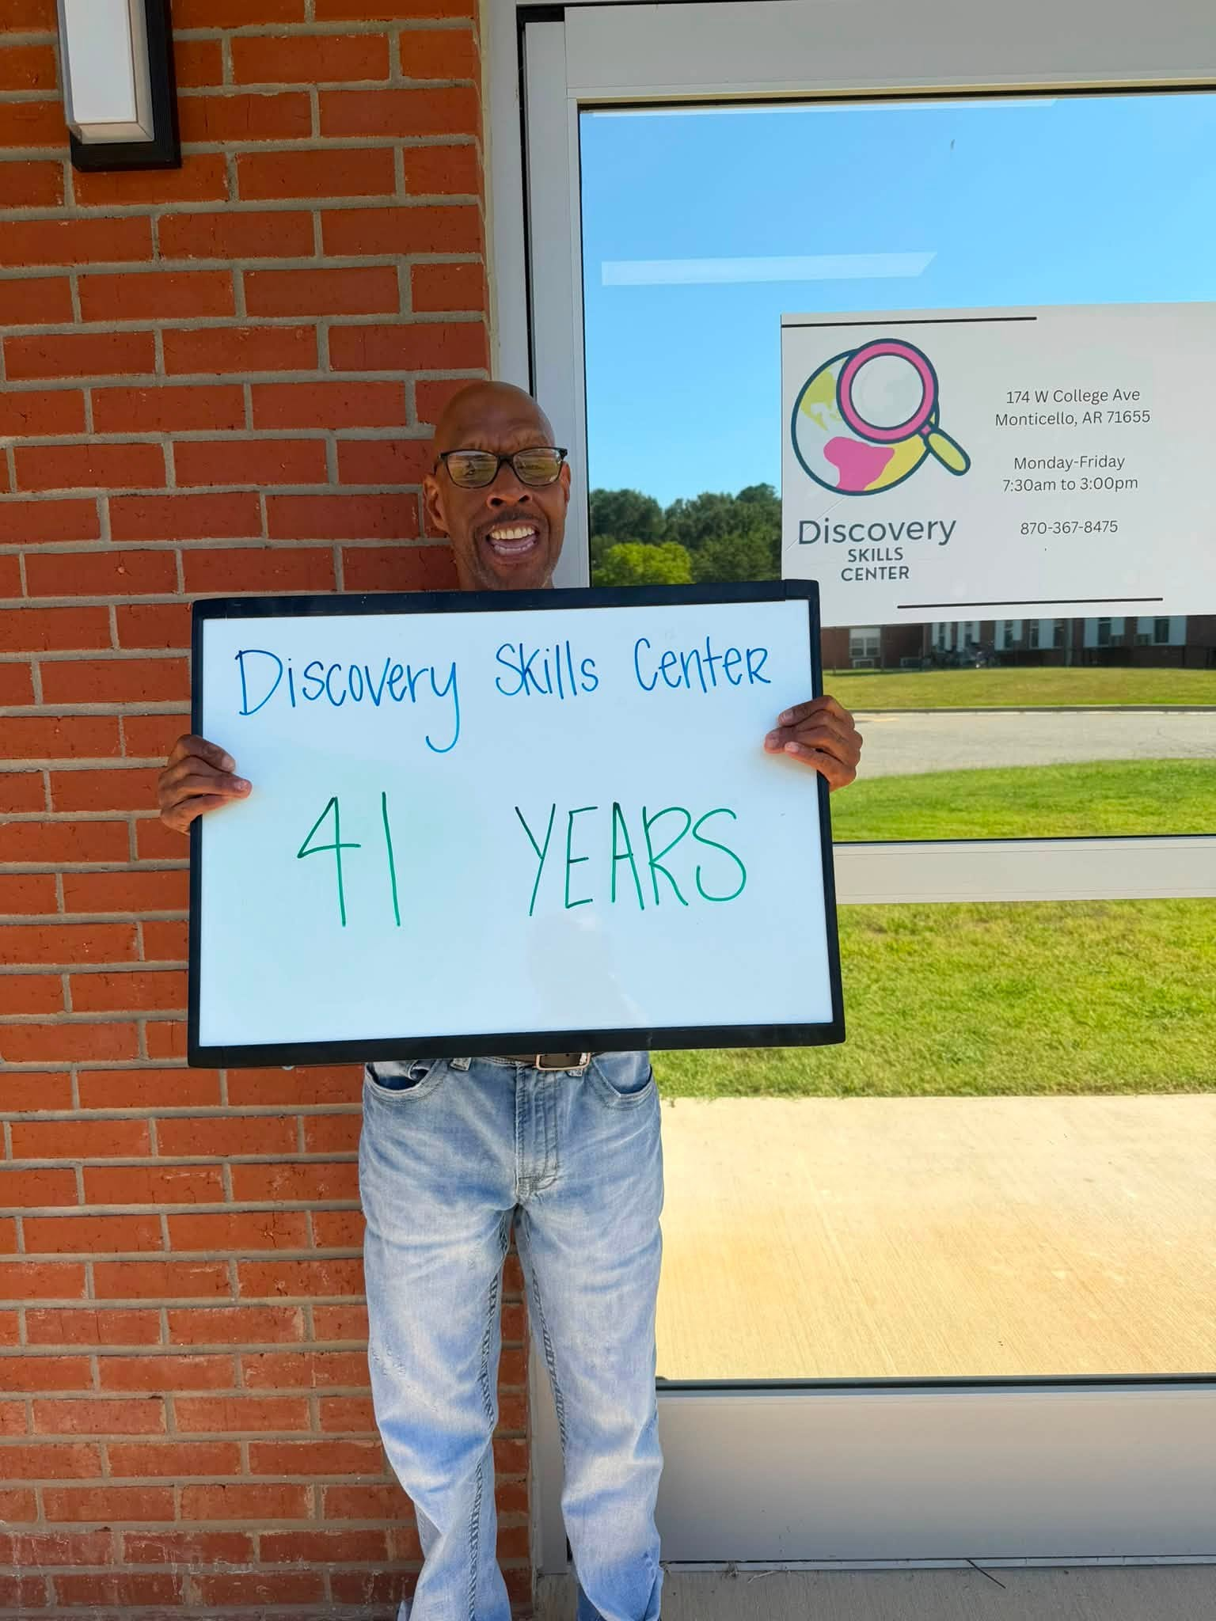

In This Report …

Board of Directors
Letter from the Executive Director
Our Facilities
Our Services
Personnel
Operating Resources & Expenses
2026 In Review
Outcomes Report
Activities

>>>>>>>>>>>>>>>>>>>>>>>>>>>>>>>>>>>>>>>>>>>>>>>>>>>>>>>>>>>
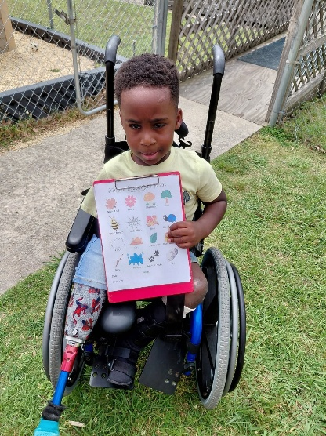

2026 Board of Directors
Dr. Lynne Thompson, President
Mr. Jamaal Jones, Vice-President
Mrs. Sandra Patrick, Secretary/Treasurer
Mrs. Trinia Isaac, Member
Mr. James Sanders, Member
Dr. Tim Simon, Member
Mrs. Susan Wishard, Member
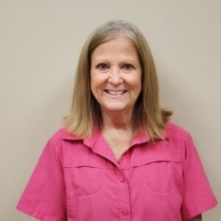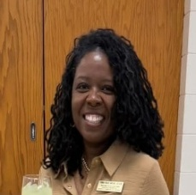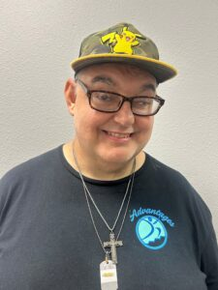
About our Board
Advantages, Inc. is governed by a volunteer Board of Directors. The membership of the board represents families, professionals, and the community at large. This valued group of volunteers use their time, energy, and expertise to provide overall direction to the organization, set policy, and approve the annual budget. Board meetings are generally held on the fourth Tuesday of each month at 3 p.m. and are open to the public. Meetings are held at Discovery Children’s Center in Monticello.

Our Mission Statement
The mission of Advantages of Southeast AR, Inc. is to provide a community-based service system of individualized instruction and support geared toward maximizing independence, self-support, employment opportunities, and normal living for persons with developmental disabilities in our 14 county service area.

“Leadership is not about being in charge.It’s about taking care of those in your charge.”
– Simon Sinek

Letter from the Executive Director
We are pleased to present our annual report for FY 2026. The information provided in this booklet is an overview of the services provided and the accomplishments achieved in 2026.
We are continuing in our 55th year of operation and we remain dedicated to our mission of providing a community-based service system of individualized instruction and support geared to independence, self-support, employment opportunities and normal living. Once again, we passed our external financial audit with zero findings and had zero deficiencies noted on our waiver audit. We completed construction and moved into our new ADDT building.
Our agency continues to provide quality services. Our Board of Directors and management team are following service/funding trends at both the federal and state level. We remain committed to maximizing funding available to ensure that we offer quality services to the individuals and families that we serve.
Programs central to our operations include Discovery Children’s Centers located in Monticello, Hamburg, and Star City; Discovery Skills Center located in Monticello; and our Waiver program based in Monticello, but encompassing 14 counties. We also provide supported employment and occupational, physical, and speech therapy services to qualifying individuals. On behalf of our Board of Directors, our dedicated staff, and the people we serve, we are committed to continuing our efforts to provide meaningful and effective programs.

-DeAnna Doherty, Executive Director


174 West College,
Monticello, AR 71655
Our Facilities
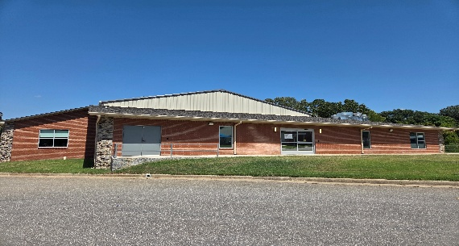

178 West College,
Monticello, AR 71655
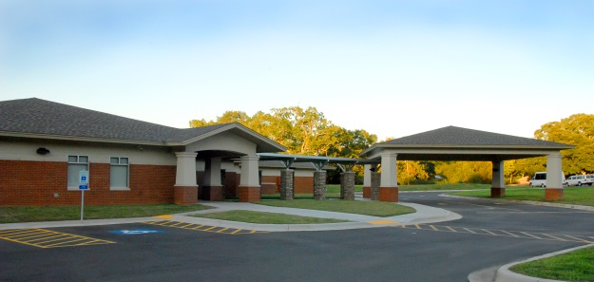

1036 N Main St,
Hamburg, AR 71646

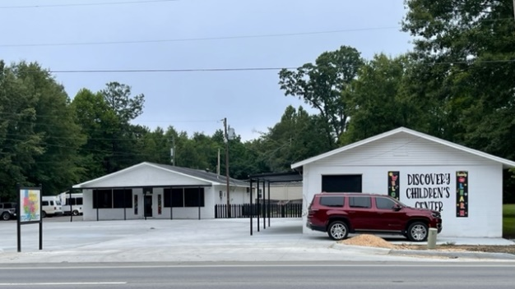 706 East Arkansas St,
Star City, AR 71667

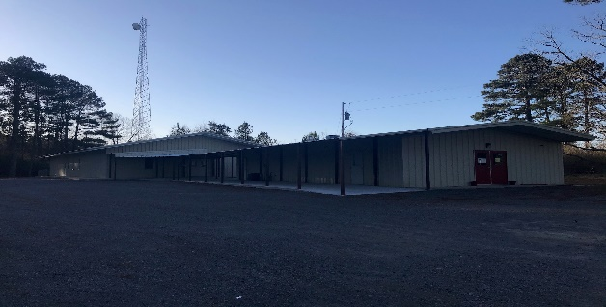

Our Services*
We offer an adult development day program (ADDT) that we call Discovery Skills Center. Discovery Skills Center is open Monday thru Friday 730 am until 3pm and is open to adults over 18 that meet the DDS and Advantages, Inc. entry requirements. The center is open year round with the exception of major holidays, and Christmas break. Each participant has an individualized program plan that targets skill areas such as personal hygiene, daily living, job preparedness, technology, and creative expression. We offer community integration and volunteer opportunities during the program year as well.

We call our early intervention day treatment services (EIDT) Discovery Children’s Center. Our preschool centers are located in Monticello, Hamburg, and Star City. The preschools operate Monday thru Friday 730 am until 3pm and are open to children ages six weeks to school age that meet the DDS and Advantages, Inc. entry requirements. The centers are open year round with the exception of major holidays, Christmas break, and Spring break. We offer a low staff to child ratio, certified teachers, and physical, occupational, and speech therapists at each center. Each child attending Discovery Children’s Center has an individualized plan as well as being exposed to core preschool curriculum which include age and topic appropriate field trips.

Our community waiver program provides needed supports for individuals with disabilities that want to live in the community. Participants in this program are provided with individual staff and a plan of care approved by their PASSE. Waiver participants work on a host of skills including budgeting, banking, hygiene, and appropriate interpersonal communication. We also provide financial management services to participants of the waiver program.

*For a complete list of services, contact our office at 870-367-6825.
Our Personnel

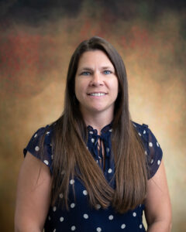





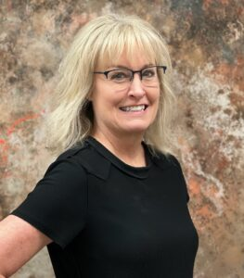
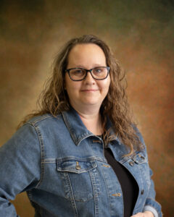



Administration
DeAnna Doherty, Executive Director
Angie Burton, Finance & Human Resources
Shanie Berry, Corporate Compliance
870-367-4383

Waiver Specialists
James Scott John Hadley
Helen Schlessinger Darlene Williams
870-367-6825

Discovery Children’s Center
Jennifer Chisholm, Preschool Director
Monticello, 870-367-4333

Becky Griffin, Preschool Director
Hamburg, 870-853-0857

Holly Carpenter, Preschool Director
Star City, 870-628-3097

Discovery Skills Center
Neal Doherty, ADDT Director
Monticello, 870-367-8475
Advantages, Inc.’s FY 2026 Operating Resources

Advantages, Inc.’s FY 2026 Expenses

FY 2026 Something to Talk About
*This section is to highlight the Top 5 accomplishments for this FY*

- We completed construction on our new ADDT building and moved in to it in January.

- Our waiver division, once again, received zero deficiencies on our annual state audit.

- Our Star City Infant/Toddler Program received a TOP 5 rating for the Best Class Scores in Early Childhood!

- We hosted Rep. Kyle Day and Senator Harrell Wilson. They enjoyed a tour and learning about our service and financial impact in Southeast Arkansas.

- We received a Summit Utilities grant to purchase upgrades for our technology lab.



Outcomes Report
Outcomes are goals that are set by Advantages, Inc.’s management team. Advantages, Inc. monitors the goals and reports quarterly to the management team and annually to stakeholders. Goals are set in each division and are categorized as efficiency, effectiveness, access, and satisfaction. Satisfaction is reported in the Stakeholder Satisfaction section. The information presented below is the measurement of a sample of Advantages’ goals for the 2026 FY. A complete review of outcomes is available in our performance improvement plan.
Efficiency:
Conduct service to billing audits in each division.
-Met, audits completed for all divisions including therapy.

90% of EIDT binders will be checked within 2 business days of receipt.
-Met, with 100% of EIDT binders checked within 2 business days of receipt.

Effectiveness:
Risk reduction drills are conducted in all departments.
-Met, all drills for all departments conducted, per the safety team coordinator

5 waiver clients will master a technology skill.
-Met, with 20 waiver clients mastering a technology skill over the course of the FY.

Access:
Maintain monthly Medicaid eligibility checks.
-Met, monthly checks are run for every consumer with results sent out.

90% of service authorizations will be issued within 45 days of referral date.
-Not met, 0% (0/1) of waiver authorizations for services were received within 45 days of completed referral.

Activities
Participants are offered a wide variety of activities that include community outings, visitors, and volunteer opportunities.

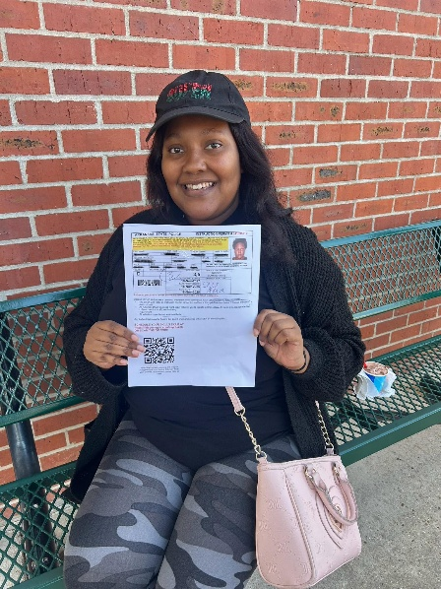





Advantages of Southeast Arkansas, Inc.
PO Box 359
Monticello, AR 71657
www.advantageseark.org

